Qikiqtarjuaq Newsletter # 4 FEAST or FAMINE February 6, 2012
It’s funny how life in the North exists in extremes.
Both weather and way of life exist in the extreme.
The sun disappears for months in the winter. Total darkness descends like lead. Everyone gets up in the darkness, goes to work in the darkness, ski-doo’s in the darkness, hangs out in the darkness, hunts and fishes in the darkness...
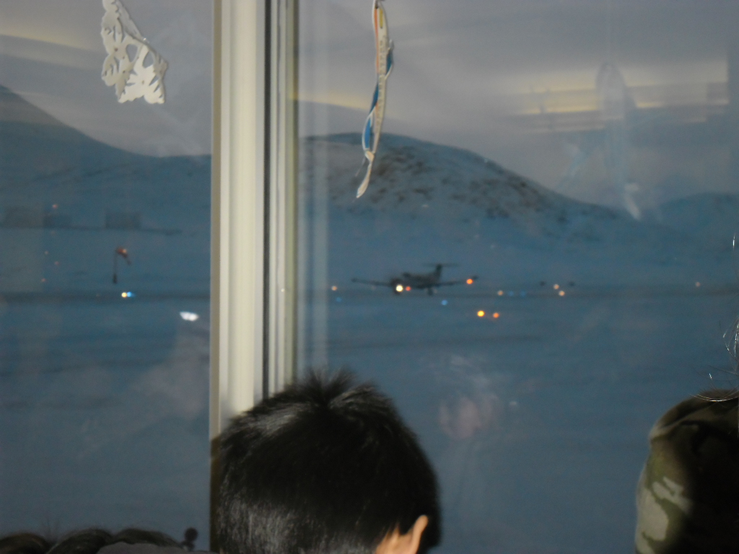 Students at Qikiqtarjuaq airport at 10 am waiting for Santa to
arrive.

For those few winter months, a blanket of darkness surrounds Arctic existence ---and oh but it is hard to get up in the morning!!!!!!!

Then comes late spring, when the sun returns and shines non-stop 24 hours a day. And everyone gets up in the light, goes about their business in the light and, eventually, some of them go to bed in the light. I say “some” because those are the months when many stay up as long as they can and fall into bed exhausted because a body can only go so long without rest.
Land of the midnight sun. 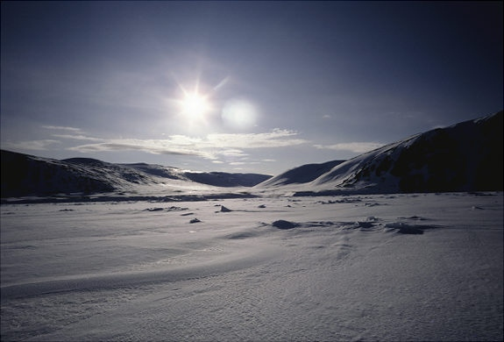

I always ask my tired students, “What time did you go to bed?” More often than not they answer, “We didn’t.”
Oh but it’s hard to go to bed!!!!!!!

That’s the weather. Extreme weather.
That HAS to have an effect on a person’s lifestyle, doesn’t it? I mean, not just in sleep patterns, but attitude, behaviour, decisions, even food and what and when they eat is determined by the weather up here.

For instance, the Inuit have what they call “a feast”.

Now, a feast to a “Kablunak” (a person from “down south”) might picture a layout of various scrumptious dishes such as turkey, ham, roast beef, potatoes, veggies, salads...here’s a photo of the “feast” Christine and I prepared for our friends in Qikiqtarjuaq this Christmas...lots of dishes...
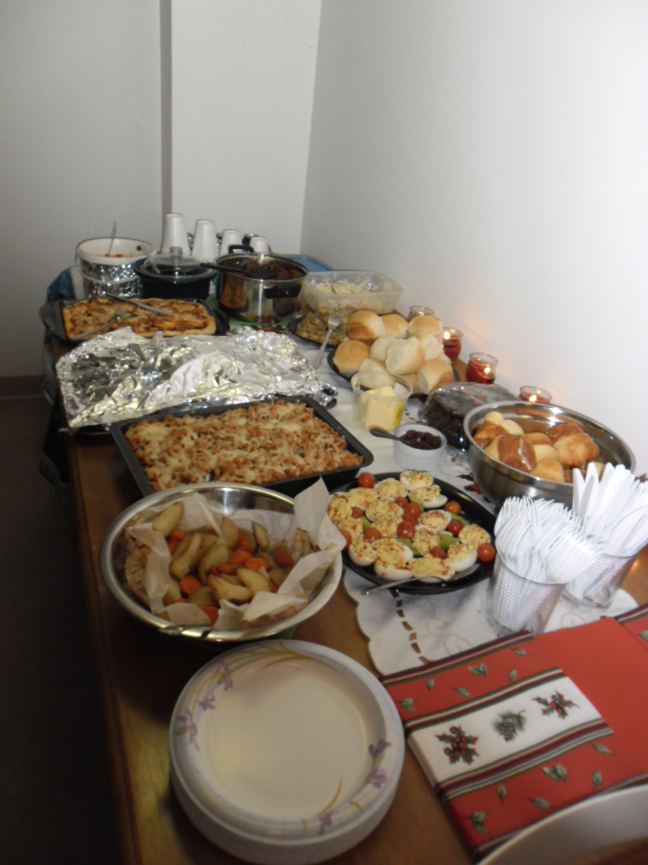 and of course desserts of all kinds... 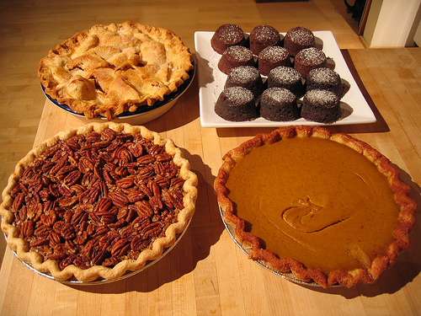

Feasts “down south” are based around seasonal traditions such as Christmas and Thanksgiving and Easter and family reunions.

The Inuit, on the other hand, feast when there has been a successful hunt or fishing spree. In a way, I guess you could call that tradition too, since they’ve been doing this for 5,000 years! When there is plenty of seal, char, walrus and whale meat, they let the community know by word of mouth. “There’s a feast at the hamlet today at 4:00” they’ll tell you. They even announce it on the local radio station. Everyone ---Inuit and those of us from “down south” --- everyone is invited to the “hamlet” or community centre to share in the wealth.

Families arrive on their ski-doo’s with their knives and their appetites; and after a prayer by the mayor, everyone kneels down to the RAW meat laid out on cardboard on the floor and digs in.

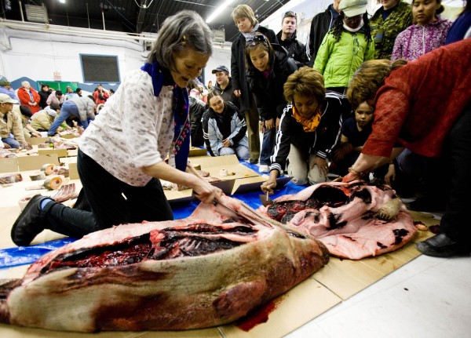
I remember one time when I was living in Clyde River, the last Inuit community I taught in, and I was invited out to an Inuit family’s camp in Inugsuin Fiord for the weekend. As their boat rounded the cliff in a huge bay, there before us was an Arctic paradise, with a panoramic view of mountains, glaciers, and a long winding untouched beach.
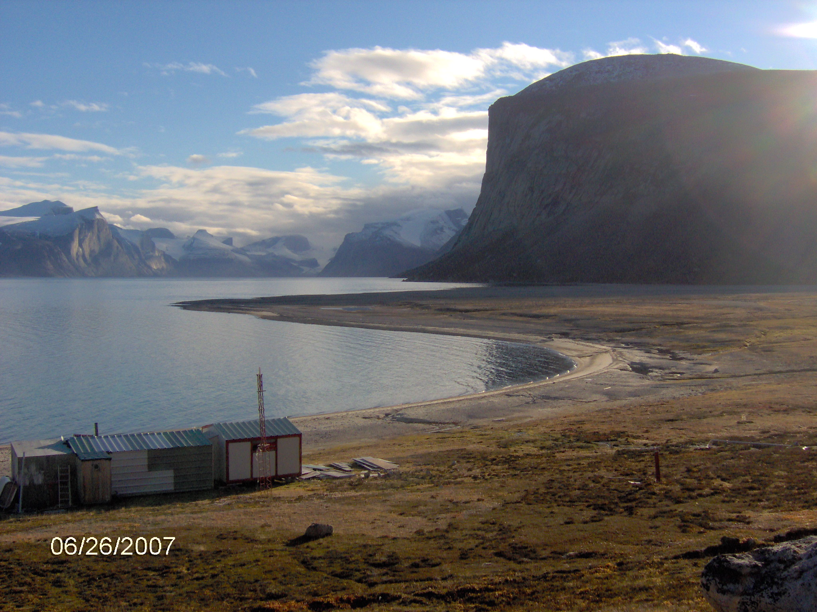

The cabins were makeshift shacks, with no electricity or running water ---but we didn’t care. It was a gorgeous autumn day, the sun was shining and we were far from civilization.
After the women and children climbed ashore with our few belongings, the men went off to find us dinner. An hour later, I was shown how to make a heather fire. With no trees and thus, no wood to burn, it’s the only thing around to make a fire---smoky---but a fire nonetheless.

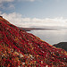 Arctic heather

Two hours later the men returned. Proudly they showed us their catch: 7 ducks. “A feast,” they said, “we’re going to have a feast.” The birds were prepared for the pot of boiling water, and within an hour we sat down to our feast. I will never forget them giving me two duck legs to eat, and saying “you get the best part”. To be honest, I did feel honoured...but, with my “down south” attitude, I have to admit I did look around for what the meal might also include...potatoes, rice, salad, veggies? Nope... that was it...that was their feast. For the rest of the visit, I ate nothing but a box of crackers I had brought, and lots and lots of tea.
Feast or famine.
More often than not the Inuit people go hungry. They will go for weeks with no food in their cupboards, instead, living off the goodwill of the school’s pantry or their “southern” neighbours. This last Christmas, when the hamlet’s finance officer found out most of the families would not have a feast, she did something about it. As was noted in the Northern News newspaper:

Qikiqtarjuaq families get food for Christmas
Qikiqtarjuaq/Broughton Island January 9, 2012
Families struggling this Christmas in Qikiqtarjuaq were able to have a proper feast at home as the hamlet's health committee spent a great deal of its budget on food bags for everyone in need in the community.
"They gave out hams, chickens, turkeys from M&M Meats, cream and sugar, tea bags, flour, baking powder and rice, Tender flake lard, crackers and cheese, cereal," finance officer Rikki Butt said.
Most people in town were on the list, Butt said, noting only working professionals were not included in the Dec. 23 distribution.
"There is a big need for some families in Qikiqtarjuaq,” she said. "The cost of living is high and the unemployment rate is high." The hamlet health committee's budget comes from the GN's Department of Health and Social Services.

Feast or famine.
Good thing the school has a breakfast program where not only kids, but whole families come in to get that one meal of the day. Their cupboards are literally bare. They get their government cheques but not all is spent on food: there are bills to pay, and gas for the ski-doo’s so they can hunt for the food they need. And then there’s the cigarettes they’re addicted to and the drugs...yes, the drugs. How many children go hungry after breakfast because they go home to no food for the rest of the day? Too many. Far too many.
It’s ironic that literally everyone in the school rushes home for lunch, even though many of them have nothing to eat. Cheryl, the grade 5 teacher, and Josip, the high school science and math teacher, and I are the only ones who stay at school during lunch. As we were sitting in the staff room chatting away, we heard a loud knock at the front entrance. Josip went to see who it was, and grabbing his coat and ski-doo keys, he said he had an errand to run and would return in thirty minutes. When he returned, I asked him where he’d gone...I can’t help it - I’m nosy!!!
“That was Tony,” Josip said. “One of the best carvers in town. He needed money.”
“Why?” I asked.
“Well, four days ago he showed me this amazing 5 foot walrus tusk and I asked him if he’d carve some Inuit scenes on it for me. He said he would if I gave him $600 to get him started. So I gave him the money --- but he’s already spent the whole damn amount! And that was only four days ago! Said his kids are hungry and he needs $60 more. So I took him to the Northern to get some money.”
“Do you think you’ll see the carving?”
“Oh yeah,” Josip said, “he’s done other carvings for me...I just hope he spends the money on food and not gambling.”

Gambling is another problem up here. Often the kids come to school warn out, exhausted, because their parents have been up all night betting and playing games involving animal bones and money.
According to Nunavut Health and Social Services:
“In Nunavut, people gamble with lottery tickets, card games, bingo, Nevada pull tickets and over the internet. Nunavummiut sometimes gamble in each other’s homes and bet large amounts of money, four wheelers, snowmobiles, and other important personal belongings.”
One of the games I played myself, with an Inuit elder and my senior students.
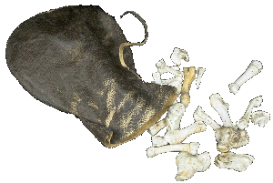gamesmuseum.uwaterloo.ca
The elder had a bag of seal bones; she took one out, and as we sat on the floor in a circle, we took turns asking a personal question then tossing the bone. If it landed one way, it was a “no” to your question; if it landed another way, it was a “yes” to your question. After an agreed-upon number of rounds, the person with the most “yes’s” won. We didn’t play for money but I could see how cash could easily be involved. If you lost all your paycheque playing this and other games each night, for sure your kids would go hungry. One night an Inuit teacher won enough money to buy a brand new ski-doo the next day.
Of course, it’s more complicated than that. Besides gambling and other addictions the Inuit learned from the “Kablunak”, there’s no getting around the fact that food prices are astronomically high up here in the North. A bag of apples is $10 and a litre of milk is $8. Even though healthy food is “subsidized”, it’s still not cheap!

Cheez Whiz made headline news up here in January, when a photo was taken of a bottle with the price of $29 below it on the shelf.


And breaded chicken goes for a whopping $77!!! The subsidy program is called Nutrition North so it does not cover items that are considered unhealthy. But as many people point out, the high prices are hurting the most vulnerable people like elders and children and those on social assistance.
Feast or famine.
One of the Inuit teachers here who is a good Christian woman struggles every day with starving neighbours knocking on her door, begging for food. She is one of the few who is careful with her hard-earned money. Still, it wears on her conscience when her own people go about hungry. She gave this testimony in church during Christmas and said it was literally killing her to go home after work each day to face the knocking on her door. She confessed it had gotten to the point where she kept the lights off in her house, living in the dark, unable to face her famished neighbours. One night, she said, it got so bad, the knocking drove her to a yelling frenzy. With anger in her heart, she went to the door and yelled at the man to come in.
“Go on, take my dinner,” she said to him, pointing at a frying pan on the stove. “Go on, take it,” she screamed.
When he left, she was so filled with guilt and rage, she found all she could do was get down on her knees and cry and pray for help. She found the answer in some scripture and an act of kindness by baking the man and his family some bannock. Taking both over to his house the next day, he thanked her and said her kindness was all he needed to know someone cared. How long her kindness will fill their bellies one can only guess.
There are others, so many others.
The North is indeed a land of extremes.
Darkness and light...
Feast and famine...
They need your prayers.
May you count the blessings on your table each day!
God bless you one and all. Love Dawn
.

.

