October 22, 2011 "YOU LOVE IT OR YOU HATE IT"
Hello everyone! I am back up in the Arctic teaching again. It was a quick decision that happened over a 2 week period --- and with support and blessings from family and friends, here I am...
Are you ready for some more glimpses into life in the Arctic?! ...
I have to tell you, life up here is not for the faint of heart. You either love it or you hate it. As the 18 seater plane flew over Baffin Island, I wondered how and why in the world did people settle here? What made them come to a place of ice and snow and rock? Here are pics from the plane...judge for yourself...
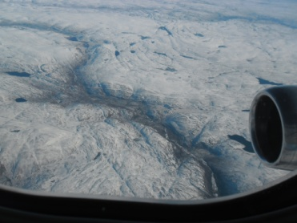 . 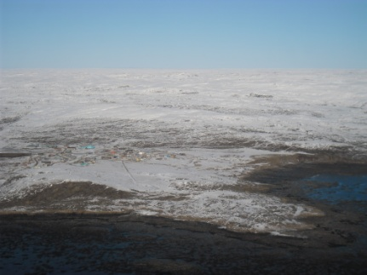
BAFFIN ISLAND from plane IQALUIT from plane – Capital of Nunavut

It reminded me of the time an Inuit woman took my students and I winter camping. When we got to her tiny one-room cabin, she looked out the window and said, “Everything I could need is out there.” After a three hour bumpy ride in a komatik sled over uneven snow, my only concern when we got there was: where am I going to go to the bathroom. She eventually showed me a hole in the snow about a hundred feet from the cabin and said, “this is where we go”. I guess her observation was right.

Headed towards my next home in the North, I wondered what Qikiqtarjuaq would look like. I knew it was smaller than Clyde River, which boasted a population of 850 people. Perched on Broughton Island off the east coast of Baffin Island, Qikiqtarjuaq has only 520 people. Broughton Island is only 16 km long and 14 km wide, so there’s not much room to roam. If you want to go anywhere, you have to travel by plane; or wait until the Arctic Ocean freezes and then you can get across to Baffin Island by ski-doo.

Qik (Qikiqtarjuaq for short) sits next to one of the most awesome national parks in the world: Auyuittuq Park, which means “Land That Never Melts”. It boasts sweeping glaciers and polar ice and the highest peaks of the Canadian Shield, one of which is called the Penny Ice Cap.
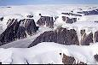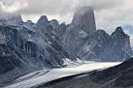
AUYUITTUQ PARK – PENNY ICE CAP AKSHAYUK PASS
Once on Baffin Island, the Inuit from Qik travel through the Akshayuk Pass in the park to get to the next hamlet of Pangnirtung. My students tell me the trip takes them about 3 hours in good weather ---and invited me to join them over the Christmas break. Remembering the scenes from the airplane, I wonder if I have the courage to try it?! Again...I ask myself: what’s out there? No bus stops that’s for sure!
I was met at the airport by the principal of Inuksuit School; Juanita happens to hail from Peterborough Ontario. Two teachers were there as well; Cheryl from Bracebridge in Muskoka, and Josip from Croatia. Three of my students were there to welcome me too, so it was quite a warm welcome, despite the -10 degree temperature. We all hopped onto 4 wheelers, ski-doos and trucks and within 5 minutes I was at my new home, a 2 bedroom dwelling sitting at the base of a huge mountain.
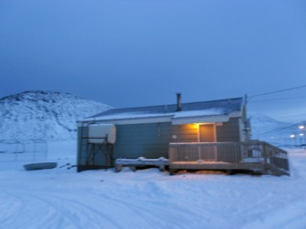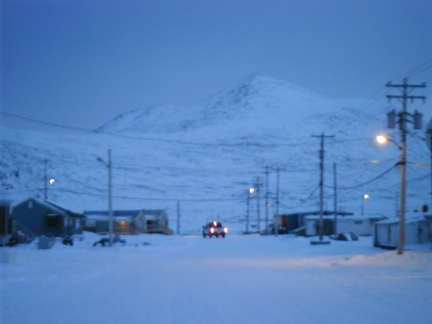

Christine, my roommate who comes from Newfoundland, met me at the door with hugs and a delicious dinner of chicken waiting on the table. Christine teaches grade 5 and is a somewhat seasoned Arctic dweller, having taught in the North for several years. But, she admits, she is getting burned out; this is her last year of teaching, period. Her vision of life in the Arctic has already turned sour---unruly students, lack of respect for the Qadlunat (white people), the feelings of “them vs us” that permeate many communities --- all of this has cemented her decision that this is it, her last year up here. To be honest, it gets challenging sometimes to come home to her complaints --- and I’ve been here only a week! But I try to stay positive and share the good side of life up here with her. Besides ---she brought a scrabble game!
Gracie, too, has her challenges. She loves going for walks, but as soon as we head out the door, a horde of dogs of different sizes and breeds, swarm around her. Even though the by-law states all dogs must be on a leash or tied up, you would never know it by the pack that appears as soon as we step outside. I do know I have to keep her with me at all times. No one’s going to hurt, hunt or trap my little furry one!
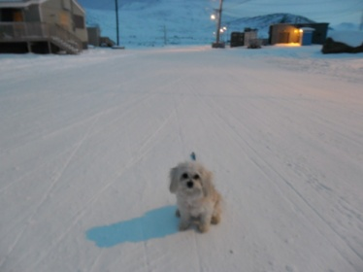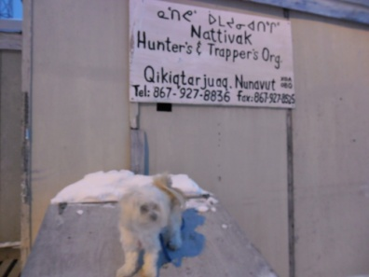
With that condition in place, Gracie told me she’s going to like her new home, no problem.

The first day I walked to work, I saw a polar bear skin stretched out on a frame. It had been caught the week before. Every day a helicopter canvases the hamlet on the look-out for bears. (Interested in a future job here, Joe?!) Just this week, three bears made their way onto the island and everyone was warned to be cautious. (Don’t worry, I am!!!)

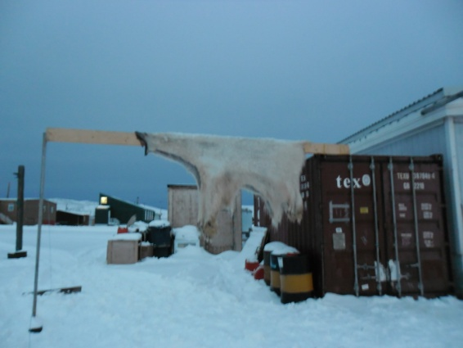 This one is over 10 feet long.

Further down the road, I saw one of the reasons why the people had settled here. The harbour is huge and deep, and surrounded on three sides by high land and mountains. Only one area remains unprotected ---the open waterway to the Arctic Ocean. Through this gap, an iceberg had made its way up the harbour and sat like a grand ship waiting to be boarded.
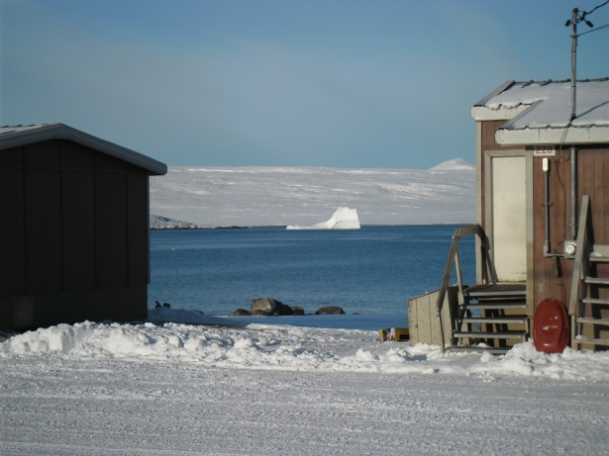

Once at the school, I stood outside the building and looked out over the grand scene. Yes, I thought, like Gracie, I’m going to like it here!

