Qikiqtarjuaq Newsletter # 6: *ALL THINGS INUIT* June 2012

As the school year ends and summer begins, it is with bittersweet feelings that I leave this place called Qikiqtarjuaq. The “Big Island” will cease to be my home in 2 days. Countdown........

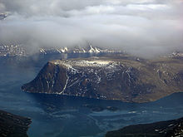

*QIKIQTARJUAK, "THE BIG ISLAND"*

The Inuit have come to mean much to me. Totally different in culture, they have immersed me in a world vastly different from my own. Straddling two worlds, the Inuit today have one foot in the past and one foot in the present. Yes, they are Canadian. No they don't live in igloos. They ride ski-doos and 4 wheelers, but still wear kamiks and seal skin clothing. They hunt with rifles, but still eat raw char, caribou, polar bear, seal and walrus. They still speak Inuktitut and throat sing and drum dance; but all the children are now bilingual. They no longer “eat bugs off each other” as one of my students wrote in her exam; but they still love to pluck out their friend’s grey hairs.

Inuit life is still very tribal.

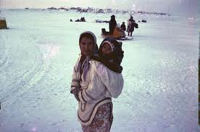

Take adoption for example. Passing a young woman pushing a baby carriage today on the road, with two young children in tow, I asked her if all three were her own.

“Nooooo,” she replied as she took a drag on her cigarette. Pointing to the tiny two year old girl tagging along behind her, she said, “That one belongs to my Mom. She was mine, but Mom adopted her.” The little angelic face of the girl smiled up at me. Proud, proud as punch.

Adoption is different up here. Not just in the way it’s done, but in the way it’s seen. “Down south” we tend to put a stigma on the word adoption. We make faces at the word adoption and conjure up images of babies not wanted by unwed mothers. Not up here. They are proud to give away their children --- to their mothers, grandmothers, aunts, cousins, sisters. The baby stays in the family. And there are no papers signed, no red tape, no government agencies involved. The new born child is just handed over, from one woman to another in trust and acceptance.

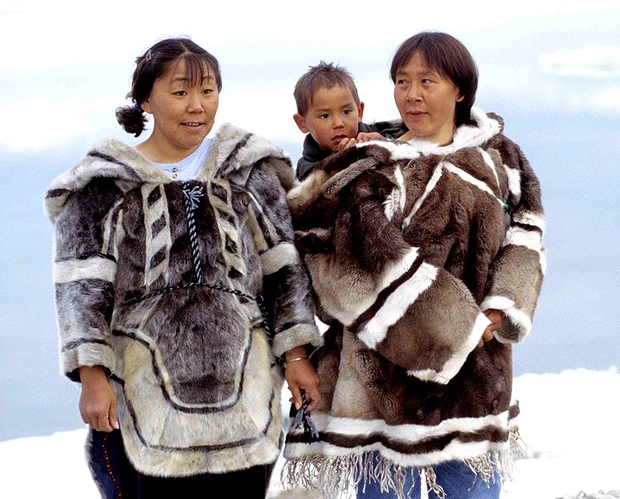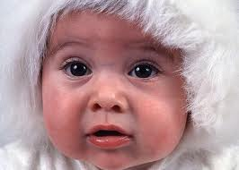

In fact, when I consider all the teenagers I taught this year, their family histories boggle my mind. Family trees up here are more like jungles than forests, with branches leading off to branches, intertwined and connected so densely, you get lost trying to figure it out. With surprise, yesterday I realized my classroom was the unofficial drop in centre for students and teachers alike, where people throughout the year had come to share, complain, unload, gossip laugh, cry and just plain talk. As I sat with Monica, one of the Inuit teachers, at the end of a long day, she watched proudly as her daughter left the room with several other students, all of them skipping to the tune of “happy birthday”. It was her daughter, Karen’s, 17th birthday. I made a comment on how Karen looked like the two friends she was with.

“They’re all cousins you know,” Monica said.

“No way!” I replied. “All these months and I never knew those girls, my students, were cousins!”

“Yup!” And she proceeded to explain her family history of sisters and brothers, and who was adopted, and who was living with who, and who the mother and father were, and even the grandparents, who I knew...but never knew they were all related. I guess in a community of only 500 people, there were bound to be a considerable number of people related; which of course, conjures up another image of inbreeding, very dangerous indeed. To be honest, they do have their fair share of disabled children.

To compare those of us from “down south” with the Inuit from “up north” is a common Arctic pastime I don’t care to indulge in; we each have our own strengths and weaknesses, not just as cultures but as individuals --- and believe me, I’ve seen examples of the highest and lowest of humanity from both sides of the hemisphere.

What other Inuit customs can I tell you about? One of the most intriguing is their use of facial expressions to convey “yes” or “no”. I’ve never heard an Inuit answer with a yes. They simply raise their eyebrows. When they scrunch up their nose, that’s a no.

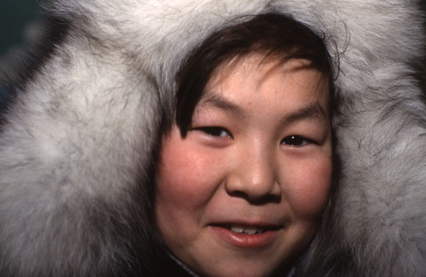

Imagine living in -50 degree weather and having to uncover your mouth to answer a simple yes or no. The Inuit are also very frugal with “thank you” and “you’re welcome” and other such niceties, even “hello” or “how are you?”. At first I found this rude; then I read somewhere that it’s not considered to be lacking in manners. As a culture they focus more on facial expressions than they do on verbal. And how shocked I was when a student loudly burped and/or passed gas within hearing! I’d forgotten those days in Clyde River when I taught Inuit students and they surprised me by saying: “Miss, it’s not rude! We do it all the time. It’s our culture!” To be honest, even though I checked with an elder on the nasty issue, I don’t think I’ll ever get used to those sounds in my classroom!

Oh well, when in Rome...

Another issue that I’ve found hard to understand, but of course I accept while living here, is the Inuit way of handling problems. Their way of handling a crisis is “don’t worry, be happy, live for today”. Meanwhile, us “white people from down south” are having panic attacks.

One day recently the principal and I were discussing this amazing difference in behaviour, wondering how and why. We were talking about the weather. Did we really think that by worrying, we could control the weather? we asked each other. When we thought about it, it seemed absurd...yet here we were worrying about our upcoming flights and checking the weather 4 days ahead of time, and asking would the planes fly and why don’t they have plans in place to keep the runway clear of floodwater and didn’t they face this problem every year and why did they wait until it happened and not be prepared ahead of time?

“Ahead of time” is NOT an Inuit concept. They live for today, not tomorrow. And so their cupboards are bare. Literally. They get money, they spend it. Then they go hungry. The snow melts and causes floods. Ok, so what’s the big deal? Tomorrow or maybe the day after, the wind will dry it up and the planes will fly. In fact I’m at home right now instead of at the school because the Inuit school council sent us home “due to flooding”. As one Inuit woman in the staffroom said when the announcement was made, “It happens every year.” The principal and I looked across the room at each other. It was our turn to raise our eyebrows.

Before I left my classroom, another Inuit woman came into my room and asked me if she could borrow some money until payday. Gambling. They were going to gamble the afternoon away. “Daisy,” I said, “you just bought your daughter a brand new $3000 dirt bike!”

“I know,” she exclaimed. “But she needs a helmet and gas.” Probably cigarettes too, I thought. Most Inuit smoke and at $20 a pack, it can get quite expensive. Each cigarette is inhaled right down to the bare butt. Nothing is wasted ---except their health. No matter how much education they get, children as young as 8 years old are seen smoking...one of the distressing things we have passed on to this great ancient culture.

Well, I was going to have a bath tonight, but we are on water rations. Because of the floods, the roads are washed out and the water trucks can’t drive to the lake and fill up. So our inside water tank has to be monitored. The same with our septic tank...don’t flush unless we have to. It’s a part of living in the north, and respecting all things Inuit.

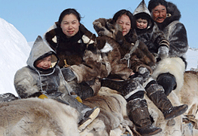

So...I’m going to do like the Inuit do: sit back and relax, have a smoke and gamble ----NO, only kidding!

However...I WILL not worry. I will not worry. I will not worry....thanks, dear Inuit, for teaching me how to live in your world.

Dawn in Qikiqtarjuaq

Sunglasses

Dog sleds

Plucking out friends’ grey hairs

Eating bugs off each other

Adoption

Going out on the land

Eating raw meat/fish

Sleeping

Facial expressions

Low key emotions

Gossip/shaming

Faith

Education

Shamans

Homes

Babies

Gambling games

Time

Long-term planning

Addictions

Amenities in hamlet

Water & septic tanks etc

Burping & farting

Empty cupboards

All things Seal